Frequently Asked Questions
GJCS TRANSPORTATION
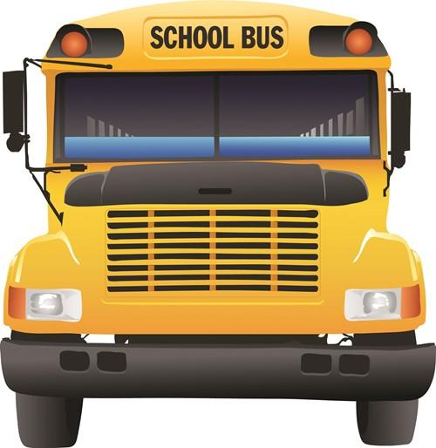
How are bus stops and routes determined?
Every GJCS student who is eligible for transportation is assigned a specific bus stop and route number. GJCS uses the Traversa software program to determine bus stops. Bus stops are located at blocks or street corners. Even though we may pass your house during the route, we cannot stop at every house. It is GJCS policy to not drop at requested businesses, etc. Please remember that we transport over one- thousand five hundred students every day, so it is impossible to provide door-to-door service to everyone, and do so in a timely manner. It is more efficient to pick up several students in one stop, usually at a corner or other mid-way point for the students.
Our subdivision does not have sidewalks and is poorly lit. How can I get the stop moved closer to our home?
Most of the sub-divisions in our district do not have sidewalks and the lighting is poor in many areas. With our Traversa routing software, and our knowledge of the areas we service, we try very hard to place our bus stops at the safest location possible. But, it is very important to remember that it is the parent’s responsibility for the safety of the child to and from the bus stop.
The bus was late dropping off my child by 5 minutes or more. Why didn’t I get a phone call informing me of the late bus?
Each bus carries 50-84 students every day to and from school. It would take a great amount of time to call each house informing them of a bus running 5 minutes late. Please do not hesitate to call our office or the school if you have a concern.
Why does my child have to sit in an assigned seat?
There are several reasons for this the first would be safety. An assigned seat on the bus helps the driver know who is on the bus. It also eliminates the child trying to find a seat at the stop, thus allowing other students the ability to deny a seat to your child. When a child knows where they sit on a daily basis it also allows for quicker bus loading and unloading. Assigned seats also help with deterring acts of vandalism on the bus.
Things are happening on the bus that the driver doesn’t do anything about—why?
The drivers first and foremost responsibility is to drive the bus to ensure that students are transported in a safe manner. They cannot see everything that is happening on the bus at all times. If something is happening on the bus that concerns you and your child, please contact the principal of your school or call our office so we can assist. Most often the driver is not aware there is a problem. However, each driver is happy to assist and make every child’s bus ride a safe and enjoyable experience.
My child is being threatened by another student on the bus. What should I do?
All school bus discipline problems should be immediately reported to the Principal of your child’s school. Students who continue to cause problems can be removed from the bus for a period of one to ten days, or permanently, depending on the nature of the disciplinary problems.
My child was running towards the bus and the driver looked at him/her then drove off. Why?
While it might look as though the driver “looked at the child and drove off” it is simply not the case at all. Drivers must check all the mirrors on the bus before moving. By looking at the mirrors it may seem as though the driver looked at the child, however; the driver never saw the child. The best way to make sure your child does not miss the bus it to be at the stop earlier, about 5 minutes before the scheduled stop. Also, for safety reasons a student should never run after or chase a bus.

What qualifications must bus drivers have to drive a school bus for GJCS?
In order to qualify to drive a school bus in the Greater Jasper Consolidated School Corporation, a person must be at least 21 years old, possess a valid Indiana Class B Commercial Driver License (CDL) with Passenger (P), school bus driver (S) and air brake endorsements, and must maintain a safe driving record. In addition, prospective drivers must pass the State Department of Education approved physical examination from an approved physician.
Drivers must also complete a comprehensive School Bus Driver Training Program provided by the state of Indiana and the Greater Jasper Transportation Department.
Bus driver candidates also undergo a thorough criminal background check through the Indiana State Police Bureau of Investigation. This investigation will check applicants for any criminal history.
How many people can ride the bus?
There is no specific number. Under Indiana law, the maximum number of students that can be transported in a school bus corresponds to the seating capacity designated by the manufacturer of the bus. Thus, a 72-passenger bus can carry 72 students, regardless of their age or size. Federal regulations govern how manufacturers determine seating capacity, using a 15-inch block for each designated seating position and rounding up to the nearest whole number. Most school bus seats are 39 inches wide; dividing 39 by 15 produces 2.6, which rounds up to three seating positions per seat.
Clearly that formula is not appropriate for all students. While state law does not limit the number of students per seat, it does require that aisles and exits be free of obstruction. This means that students cannot be hanging off the seats into the aisles, and their belongings cannot block emergency exits. A further consideration is that the passive restraint system called compartmentalization works only for students who are completely contained within the seating system; a student who is partially off the seat is not fully protected. Therefore, the number of students that can safely sit on a school bus seat is the number that fits entirely on the seat.

